40 FROM BASE 8 TO BASE 2

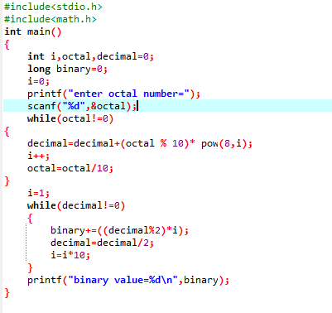

OUTPUT

